/*

program name:strong number

*/

#include<stdio.h>

int factorial(int n)

{

int fact=1;

for (int i=1;i<=n;i++)

{

fact*=i;

}

return fact;

}

int main()

{

int num,original,digit,sum=0;

printf("Enter a number");

scanf("%d",&num);

original=num;

while (num>0)

{

digit=num%10;

sum+=factorial(digit);

num/=10;

}

if(sum==original)

printf("%d is strong no\n",original);

else

printf("%d is not a strong number\n",original);

return 0;

}

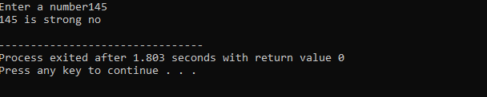**Output:**